2020

Team B.R.U.H.

Fontys

9/10/2020

Project Plan



### Versions

* Project Plan v1.0:
  + Initial document created.
* Project Plan v1.1:
  + Reorganization of the document.
    - Improved contents section.
    - Added a proper introduction.
    - Encapsulated project statement.
  + Made certain statements less abstract.
  + Added information about the team.
    - Certifications/projects.
    - Team leader contact information.
  + Reorganized the Gantt chart to better show the timeframes of certain tasks.
* Project Plan v1.2:
  + Added the application’s user distinction feature to project goal statement.
  + Added certain clarifications to the Current Situation section.
  + Removed MoSCoW from the “Deliverables” section.
* Project Plan v1.3:
  + Removed extra empty pages.
  + Removed “Content” and everything before the content section from the content section.
  + Added Management column to the “Risks” table.
  + Changed Phase 1’s name to match the visualization.
  + New additions to “Project goal” to make it more specific.
  + Added rows to Gantt chart to indicate different phases.
  + Made certain specifications on the Gantt chart to make it clearer.

## Contents

Introduction 3

Project Statement 3

Client 3

Contact information: 3

Team 4

Team Leader contact: 4

Team leader: Tsanko Nedelchev 4

Rick van Ham 4

Loek Hamers 5

Menderes Saçli 5

Current Situation 5

Problem Definitioin 5

Project Goal 6

Deliverables 6

Non-deliverables 6

Constraints 6

Risks 7

Assumptions 7

Phasing 8

Phase 1: Research 8

Phase 2: Design and Implementation 9

Phase 3: Testing and Deployment 9

Gantt Chart 10

# Introduction

The goal of this project plan is to provide all the information the reader might need about the project and its development. It starts with providing information about the client, the team, the current situation, the problem and the goal of the project. It states what is to be delivered and what is not to be delivered by our team at the end of the project. Furthermore, information about the different phases of development of the project is presented and explained.

# Project Statement

## Client

Our client is Mr.Rafayel Avetyan. He represents “Media Bazaar” - a hardware store in Eindhoven, funded by parent company “Jupiter”.

### Contact information:

We can contact our client via e-mail or by inviting them for a meeting online or in person.

Name: Rafayel Avetyan

Address: Rachelsmolen 5612, 5612 MG Eindhoven, R10 4.45

Phone: +31683233895

Email: [r.avetyan@fontys.nl](mailto:r.avetyan@fontys.nl)

## Team

Our team B.R.U.H.(Bold Resourceful United Hardworking) consists of 4 people:

### Team Leader contact:

Email: [t.nedelchev@student.fontys.nl](mailto:t.nedelchev@student.fontys.nl)

Phone: +31645688545

### Team leader: Tsanko Nedelchev

C#, HTML, CSS, JS, PHP, Angular, Laravel

|  |  |
| --- | --- |
| **Project name** | **Project Description** |
| Lego Mindstorms Project | A prototype of a warehouse robot that transports packages. |
| PROP | A project for featuring a website and several C# applications that support a rock festival. |

### Rick van Ham

C#, JS, HTML, Ruby

|  |  |
| --- | --- |
| **Project name** | **Project Description** |
| Fontys Royale | A battle royale game. |
| Stoom | A video game webshop like Steam |

### Loek Hamers

C#, HTML, CSS, JS, PHP

|  |  |
| --- | --- |
| **Project name** | **Project Description** |
| Camp 11 | A point-and-click game. |
| Webshop | A webshop with a working shopping cart. |

### Menderes Saçli

C++, Arduino, C#, HTML, CSS

## Current Situation

A new hardware store “Media Bazaar” is opening their first shop in Eindhoven. Founded by the parent company “Jupiter”. The biggest challenge that Media Bazaar’s management foresees, is keeping track of their employees and products. Currently all organizational activities is done via physical means like lists and ledgers. They hired our team of software engineers to develop an administrative system that allows it’s users to keep track of employees and products, assign shifts and display information.

## Problem Definitioin

1. The lack of a centralized system, that supports the internals of the store, negatively affects management and productivity.
2. Currently all organizational activities like the managing the stock of products and setting employee working hours are done “on paper” instead of being stored in a server’s database, which is unreliable.
3. There isn’t a reliable way available to view summaries of data like the stock of the products, the number of employees, the number of sales.

## Project Goal

Create a C# desktop application that helps solve the problems listed under Problem Definition. It will make the following actions possible:

1. The application will allow a manager to keep track of employees, products and departments – It will show certain statistics e.g. number of employees, number of employees currently working, overall stock of items, current stock available in the store, what items need restocking, list of departments, list of employees per department.
2. The application will allow managers to manage employees’ working hours (add more, change and reassign them).
3. The application will allow managers to add/remove/retire employees, products and departments.
4. The application will allow employees to manage their own personal data and view their own schedule

## Deliverables

1. Project Plan
2. Design Document
3. An application that will help in organizing the internals of the store, provide overview of employees, products and departments, manage the employees’ schedule, display and edit personal information of employees and distinguish between differrent users.
4. A built version of the application with a shortcut as well as source code of the application.

## Non-deliverables

1. Our team won’t provide a manual on how to use the application.
2. Our team won’t be involved with the application after its implementation into the working process.
3. Our team won’t provide training for employees on how to use the application.

## Constraints

1. Programing language - The desktop application will be implemented in C#.
2. Time - The initial part of the project needs to be finished and ready for presentation in week 6
3. Quality - The final product needs to be in sufficient quality so it passes the presentation to the client in week 6

## Risks

|  |  |  |  |  |
| --- | --- | --- | --- | --- |
| **Risk** | **Probability** | **Impact** | **Management** | **Prevention** |
| Member getting sick | Moderate | Moderate | Distributing the tasks that are left unattended onto the members present and reorganizing the workforce. | Wear a mask, stay 1.5m away from other poople, avoid crouded places. |
| Getting behind schedule | Moderate | High | Reiterate on what is missing and create a better schedule that will fit the new time left. | Planning – Make use of charts and comunication applications and focus on what’s left to be done and how to do it in time. |
| Low team motivation | Low | Moderate | Team Building - motivate the members of the team and visualize the goal. | Make notice in every meeting of what was achieved and try to show the team members they are valued. |

## Assumptions

1. The devices that will run the application will use MS Windows as an operating system and will have sufficient hardware.
2. The client will provide a server that will host the database of the application.

# Phasing

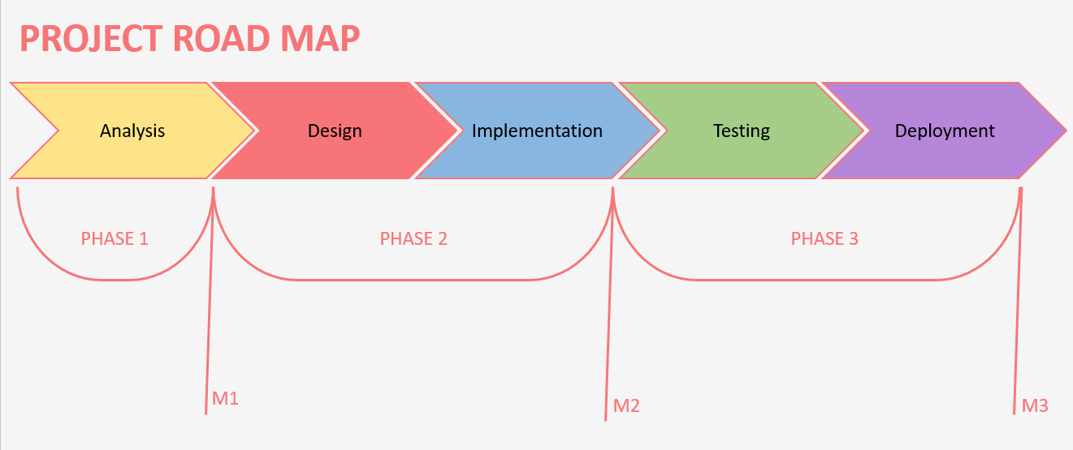

## Phase 1: Analysis

Timeframe: 2 Sep 2020 – 13 Sep 2020 (2 weeks)

Deliverables:

1. A basic design of how the application will look and function

Our task for this phase is to take a closer look at the project and analyse what is needed for it to satisfy our client’s requirements. This includes conducting a research via interviews with our client, getting professional feedback from our tutor and acquiring information online while documenting that research.

## Phase 2: Design and Implementation

Timeframe: Weeks 7 Sep 2020 – 27 Sep 2020

Deliverables:

1. Finished design of the application 7-15 Sep 2020
2. A working database 7-20 Sep 2020
3. Initial version of the application 14-27 Sep 2020

We will begin designing the application in week 2 after we have fully documented the User requirements for the project. After the design has been finished our team will start developing the application. In week 4 we should have all basic features of the application implemented and ready for the next phase. At the end of week 4 we will be ready to deliver the first version of the application to the client and ask for feedback.

## Phase 3: Testing and Deployment

Timeframe: Weeks 28 Sep 2020 – 7 Oct 2020

Deliverables:

1. Final version of the application 28 Sep 2020 – 4 Oct 2020
2. Finalized Database 28 Sep 2020 – 4 Oct 2020

In this phase our team will take in consideration the feedback from the client and make adjustments to the application in accordance with that. In week 5 we will test the functionality of the application and make sure that it is user-friendly and works fluently. At the end of week 6 we will make a final presentation to the client during which we will demonstrate the application’s features in their final state.

## Gantt Chart

## 